Assignment 2

Mansoor Zafar
Seneca College
Course Code: DPS955 NSA
Dr. Asad Norouzi
March 16, 2025

Table of Contents:
Introduction 1
Links 2
GitHub Repository 2.1
GitHub CI/CD Links 2.2
Docker Links 2.3
Screenshots 3
Conclusion 4

Introduction:
The updates given to the system since assignment 1 are: the addition of the ability to expand or not fragments if the user does GET request to /v1/fragments, the ability to get a specific fragment based on its ID as its specified content type, getting the info for a specific fragment based on its id, a way to convert markdown fragment to html and being able to make any text/* or an application Json. For the frontend UI, now the user can see all their fragments or create one.

Links
GitHub Repositories:
Fragments:
https://github.com/MansoorAZafar/fragments
Fragments UI:
https://github.com/MansoorAZafar/fragments-ui
GitHub CI/CD Link(s)
Fragments:
CI:
https://github.com/MansoorAZafar/fragments/actions/runs/13825535148
Unit Tests Specific:
https://github.com/MansoorAZafar/fragments/actions/runs/13825535148/job/38679655621
CD:
https://github.com/MansoorAZafar/fragments/actions/runs/13825535145
Fragments UI:
CI:
https://github.com/MansoorAZafar/fragments-ui/actions/runs/13885707648

Docker Hub
Fragments: https://hub.docker.com/repository/docker/mansoorazafars/fragments/general
Latest Image:
https://hub.docker.com/repository/docker/mansoorazafars/fragments/tags/latest/sha256:2399ca5d463f15c1bbf8c8255e558dabba1785b3b5a9043ce11c8be47a444417
Fragments-UI:
https://hub.docker.com/repository/docker/mansoorazafars/fragments-ui/general
Latest Image:
https://hub.docker.com/repository/docker/mansoorazafars/fragments-ui/tags/latest/sha256f52563cfbe886f50b010621b8021a486745c8dbe3d8b879ccc81a5698c73b38e

Screenshots:
Order:
- Proof Of Docker, Docker Hub & AWS
- Fragments API EC2 based on Docker Image + Health Check
- Fragments UI
  - UI being able to run on Docker or Localhost
  - User authenticating with Cognito based UI
  - Showing Users Fragments in console (later is visual)
  - User Creating Json fragment
  - User Creating Markdown Fragment
  - Showing User’s Fragments metadata
  - EC2 Adding the location header (for the json fragment)
- Running NPM Coverage
- Conclusion
Proof Of Docker, Docker Hub, AWS
Docker:
Being able to run Frontend UI on Docker
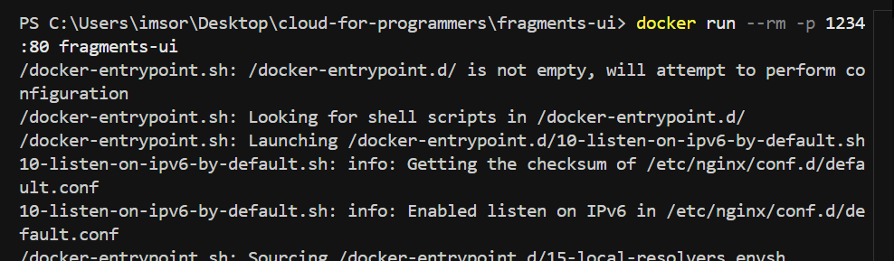
Being able to run microservice on EC2 via Docker

Docker Hub
Fragments UI
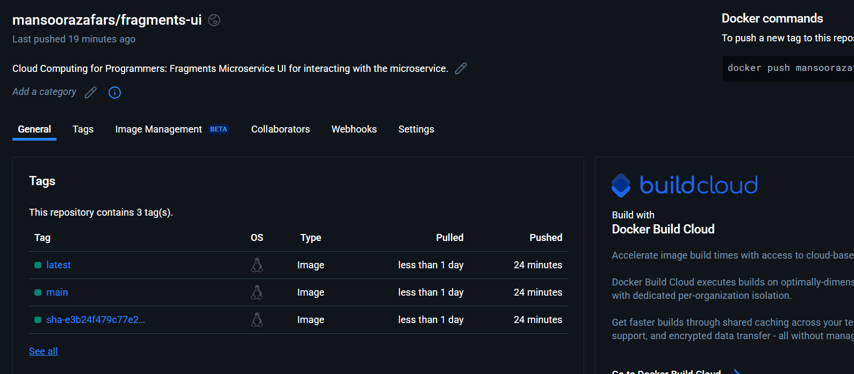
Fragments
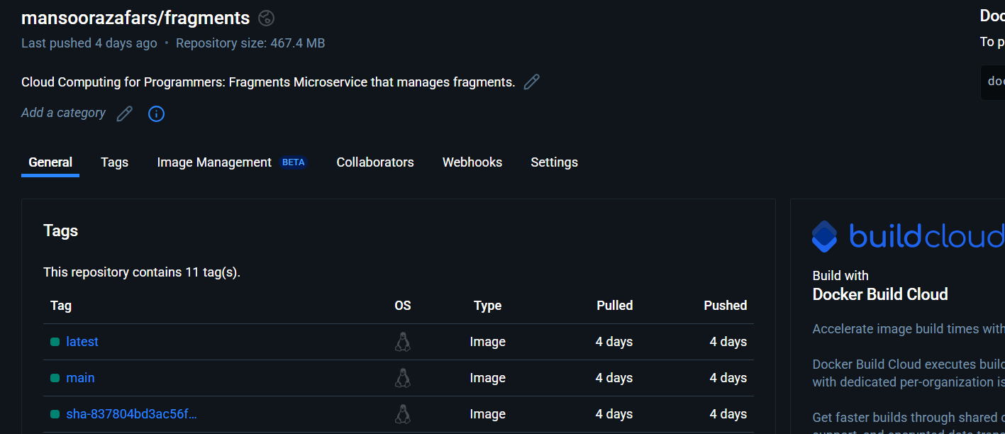
AWS
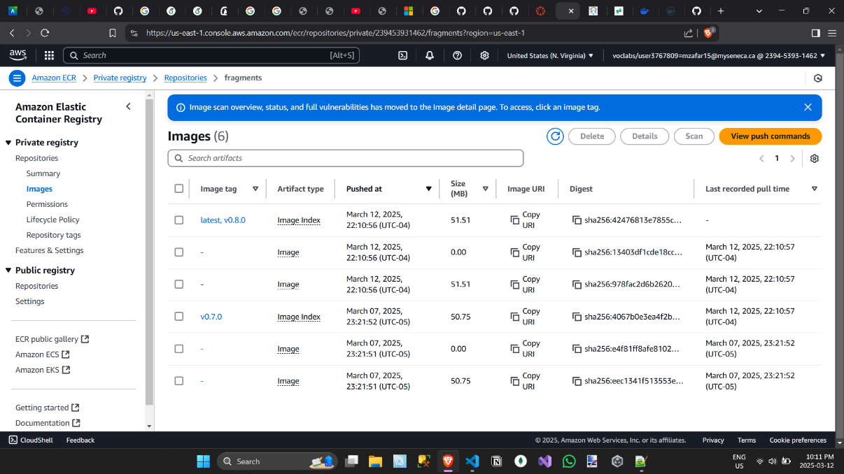
Fragments API EC2 based on Docker Image + Health Check
EC2 run based on the docker image
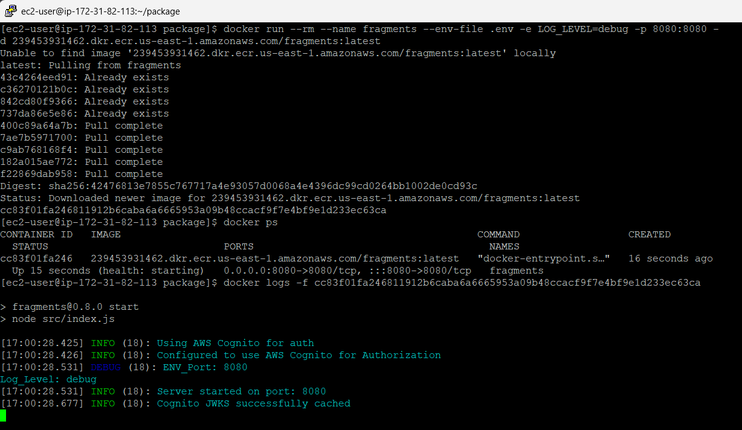
Health Check:
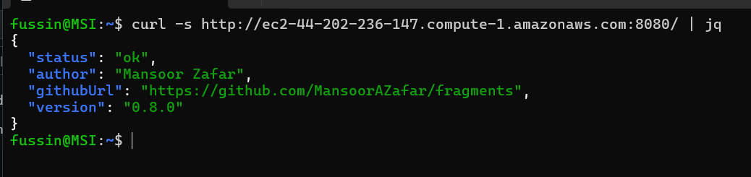
Fragments UI
Running UI on Docker

Running UI on Localhost
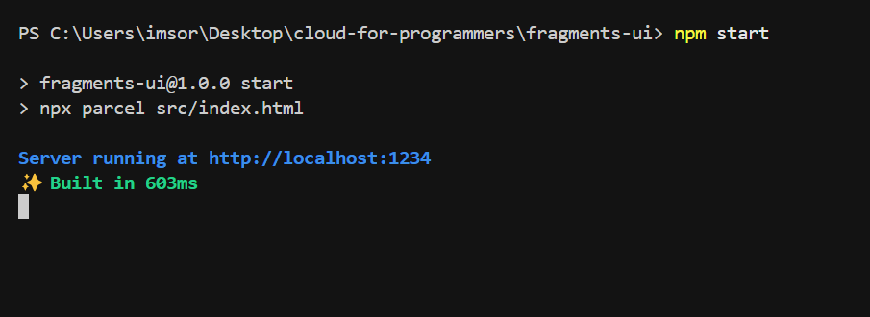
User connecting to Cognito Login
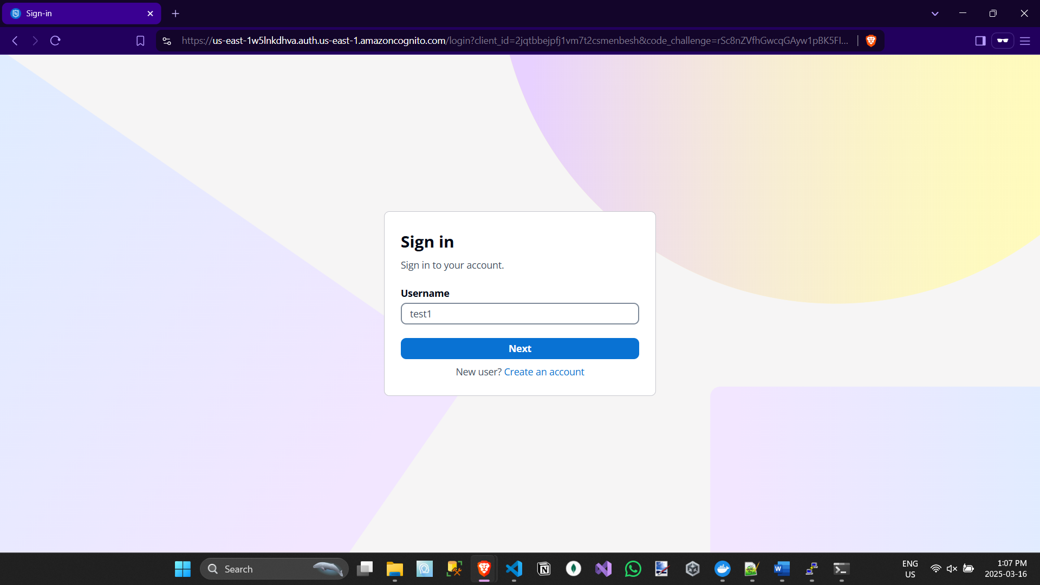
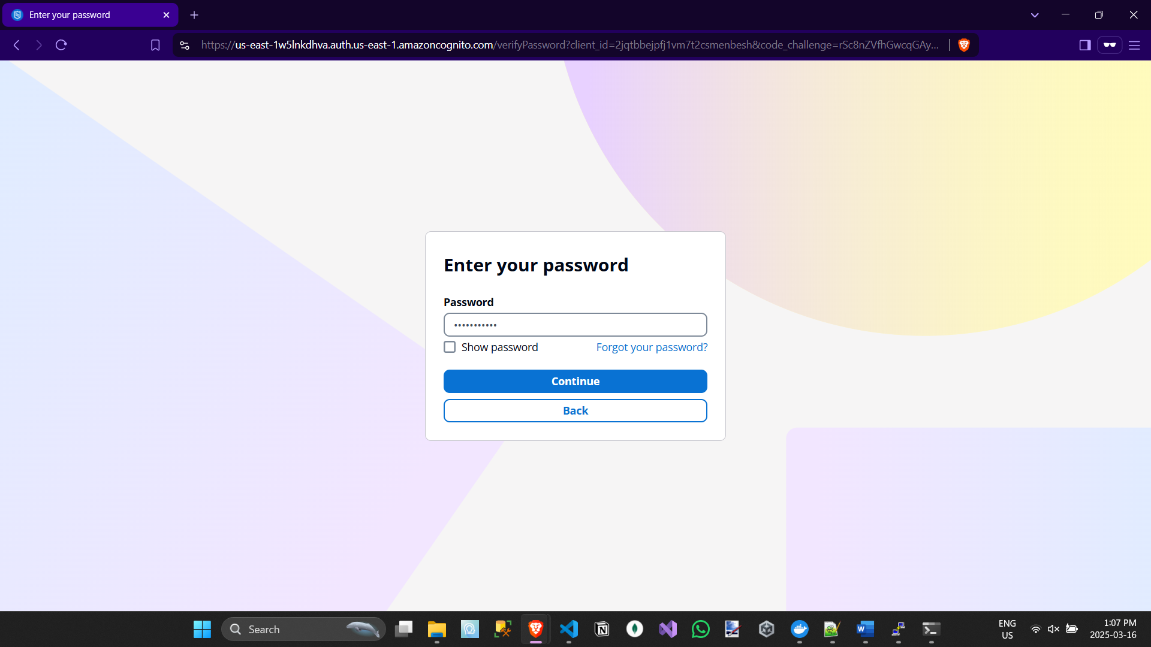
(After using logs in)
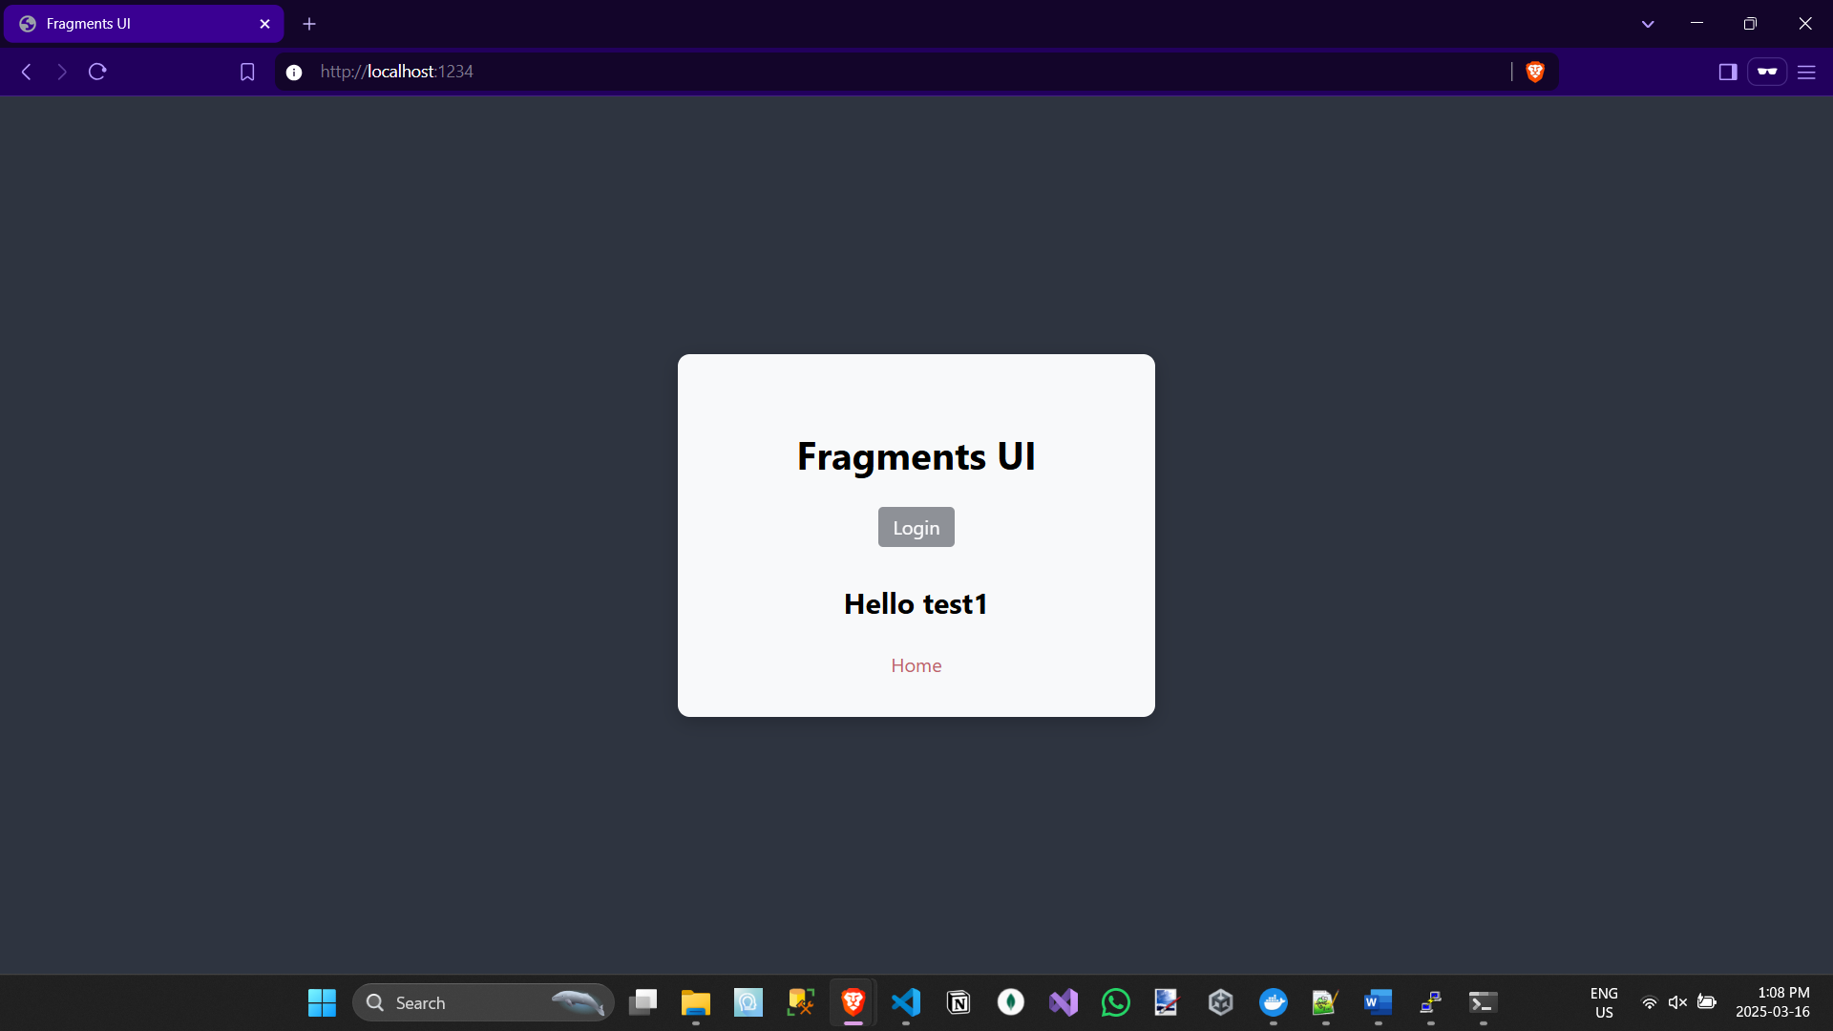
Showing Users Fragments (in console)
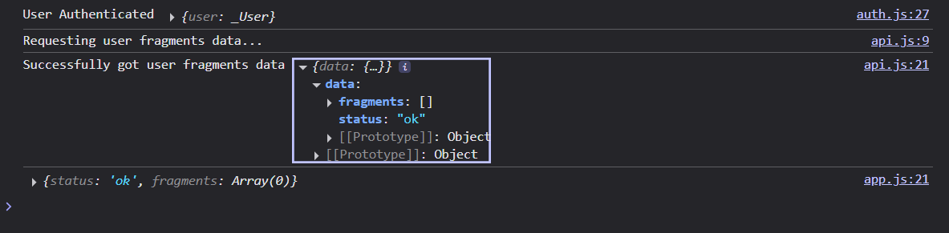
(after pressing the home link)
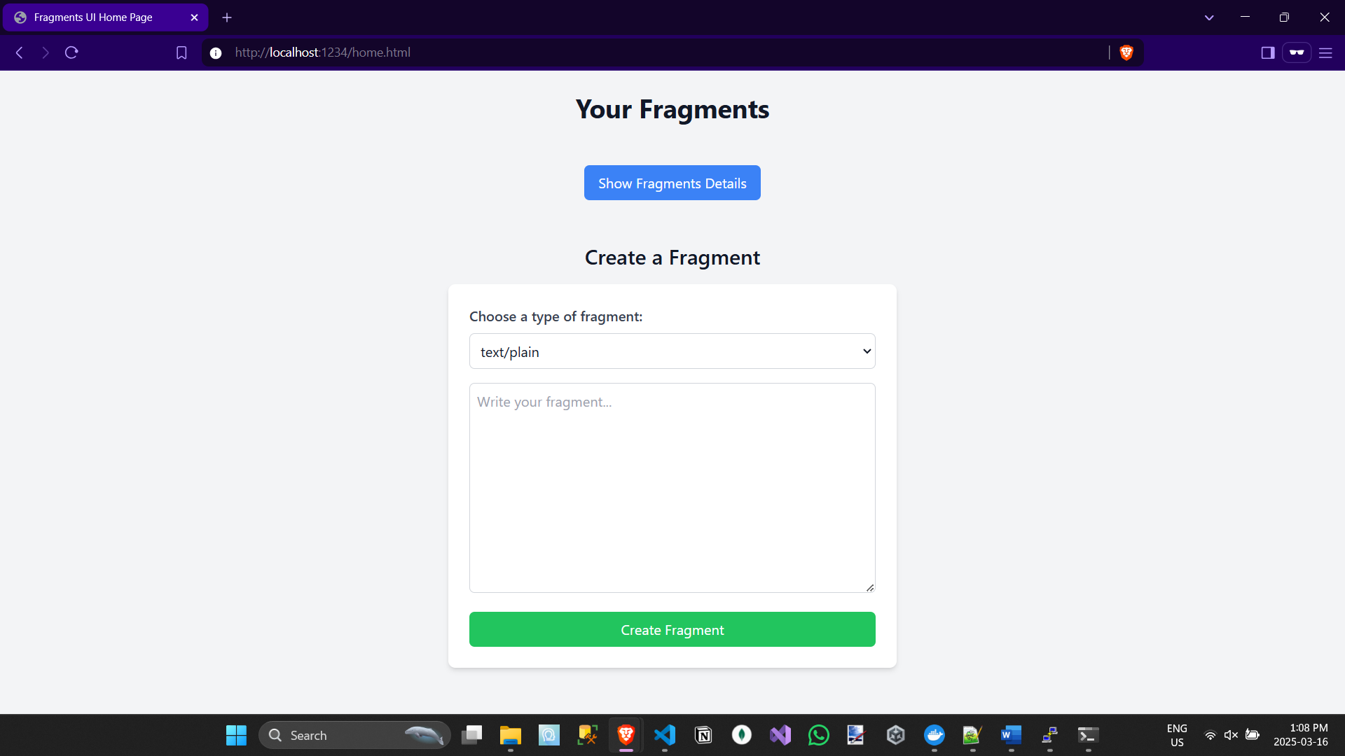
Creating A Json Fragment
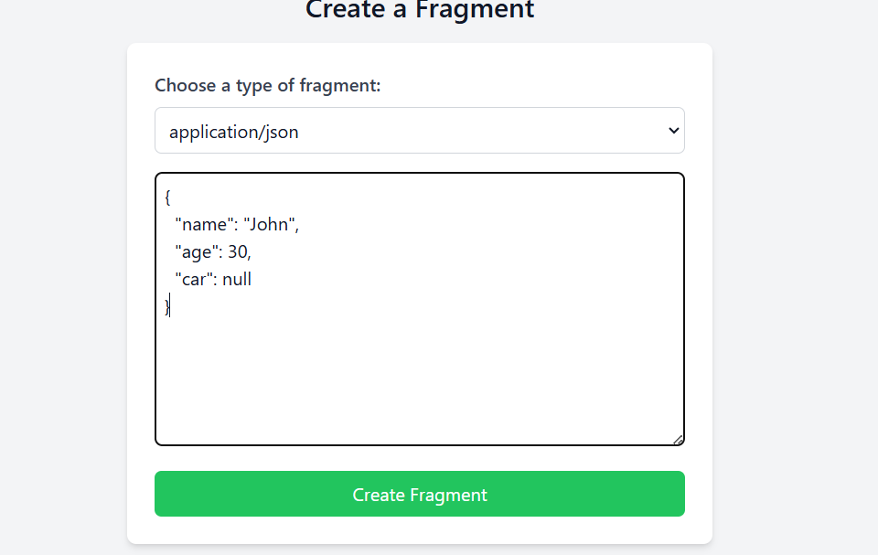
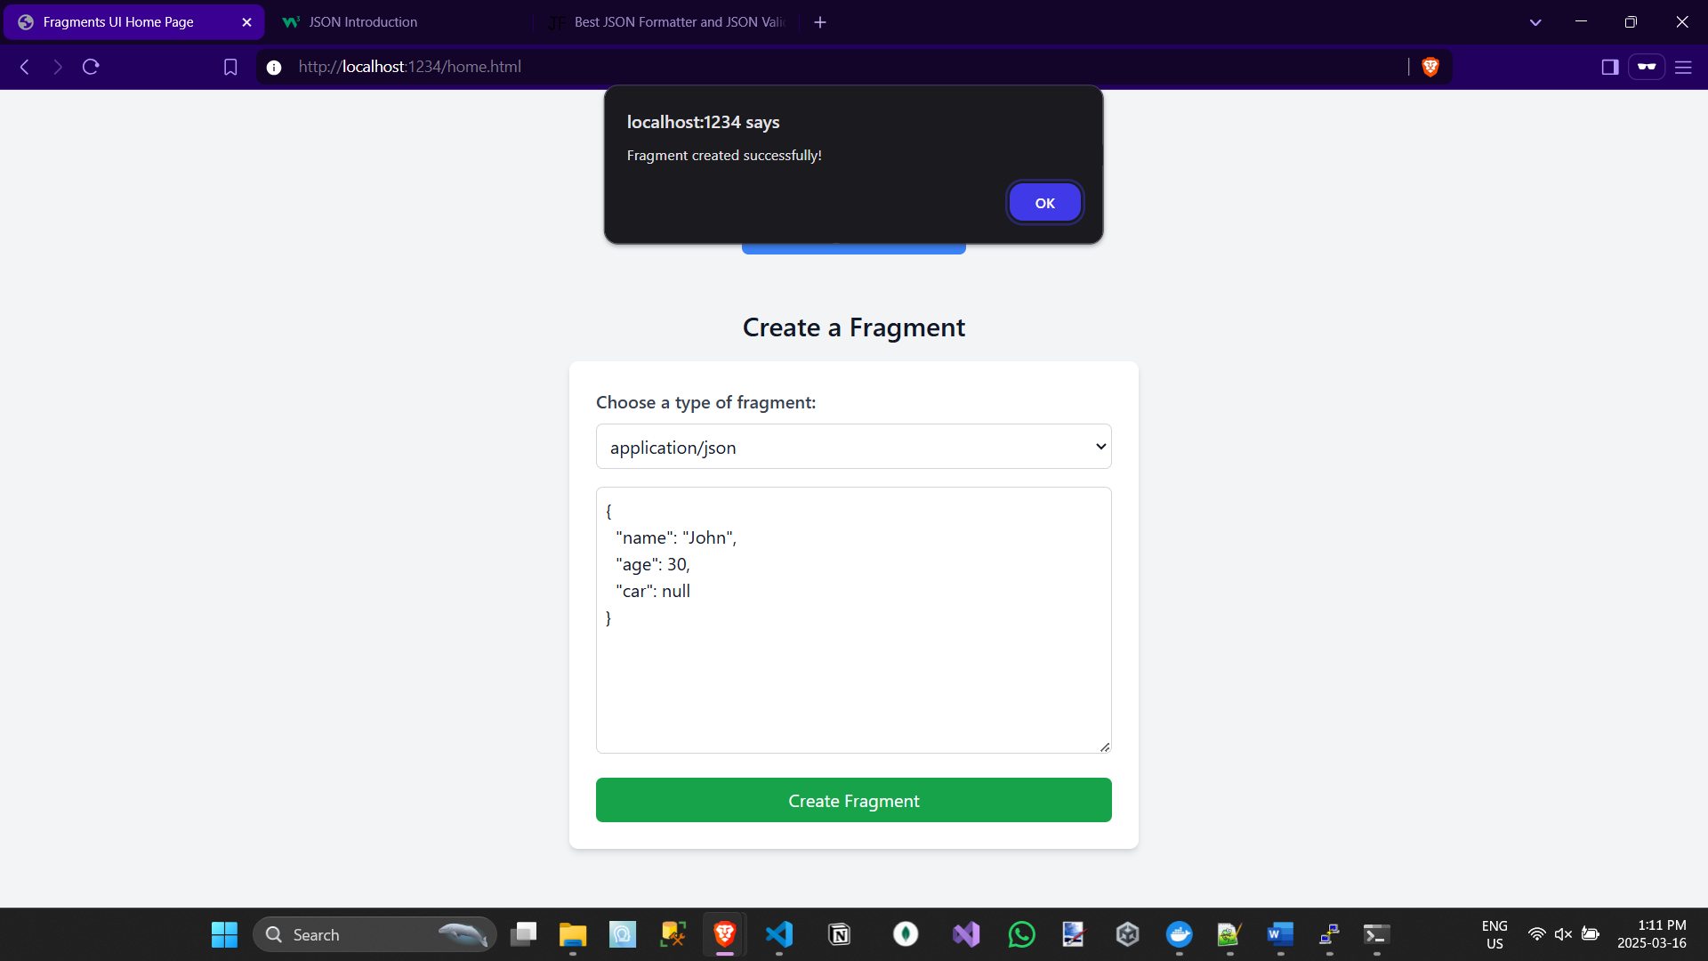
Showing all Fragments (I’ll show it again when the other fragment is added)
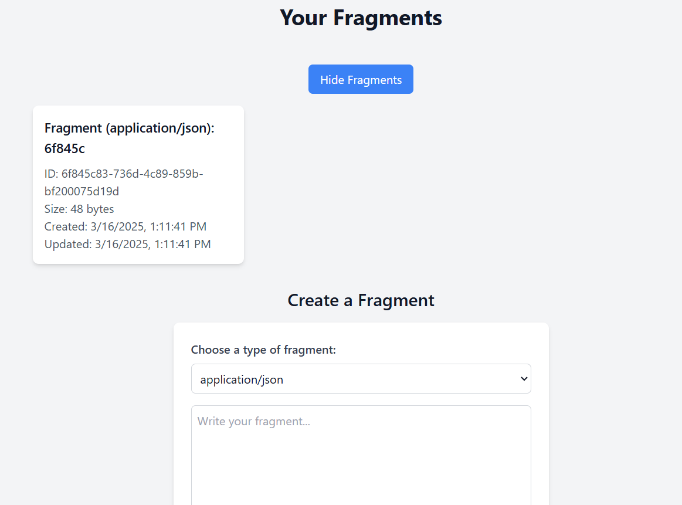
User Creating Markdown Fragment
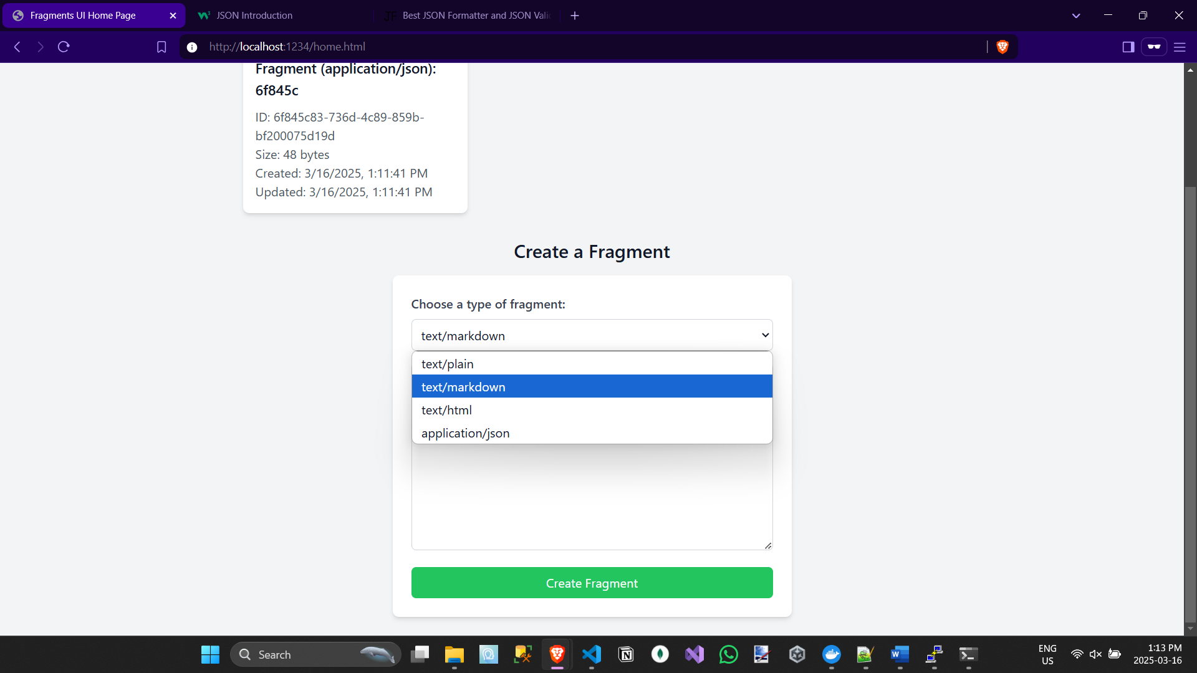
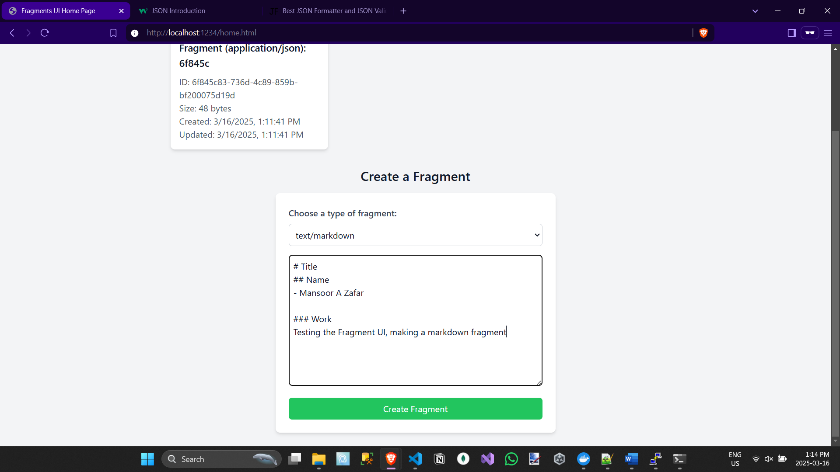
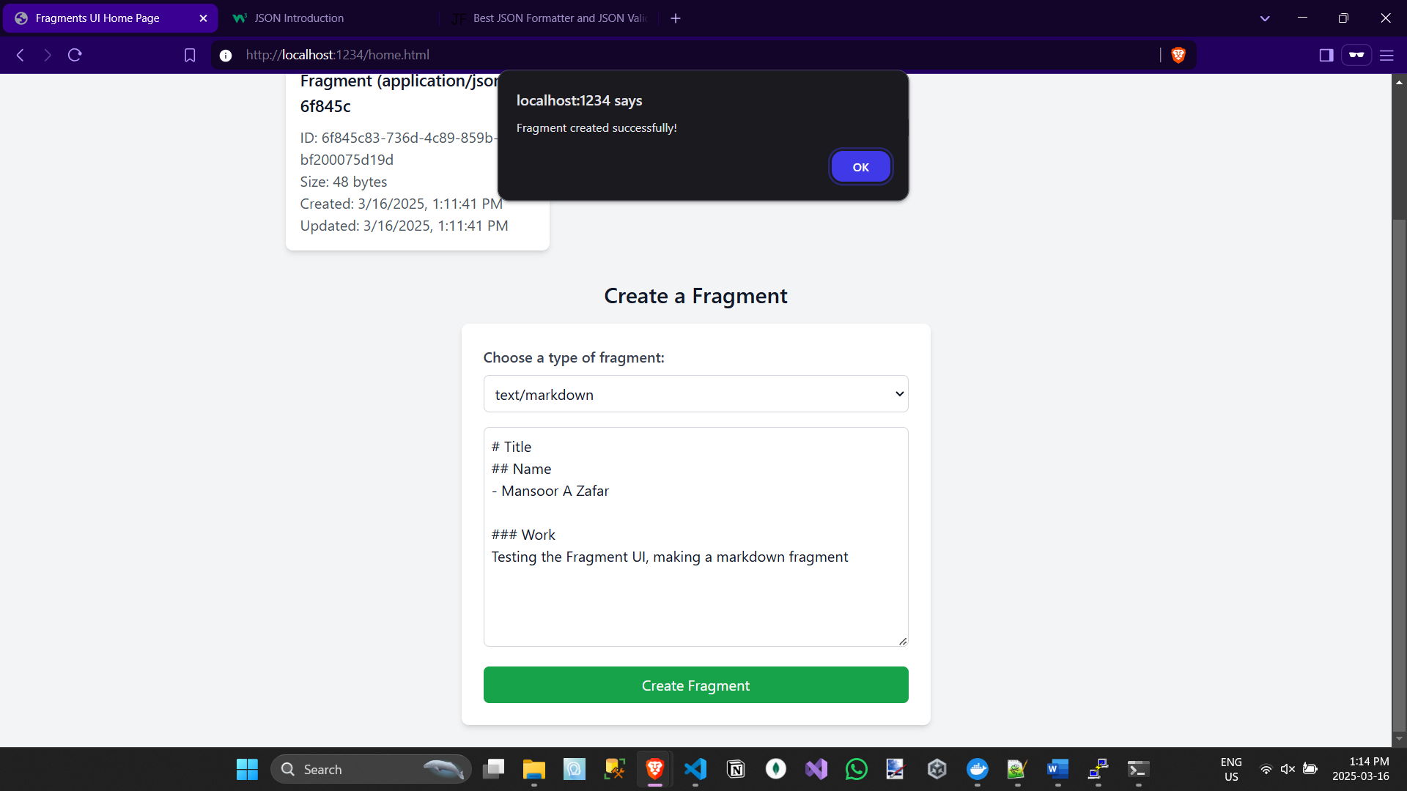
Showing All Fragments Metadata
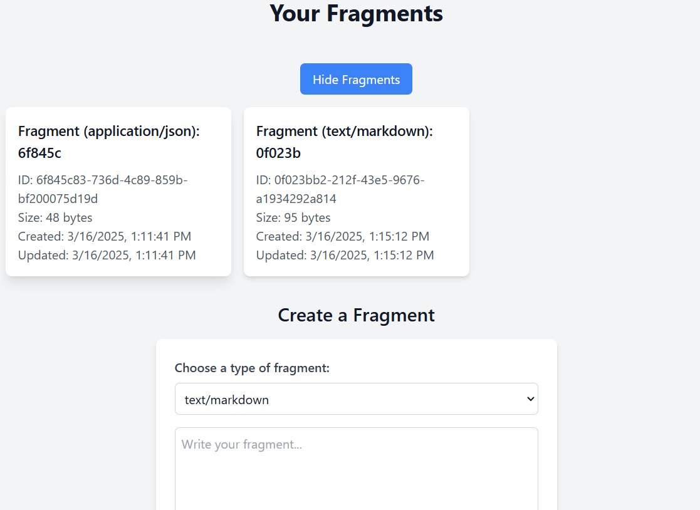
EC2 returning Location header
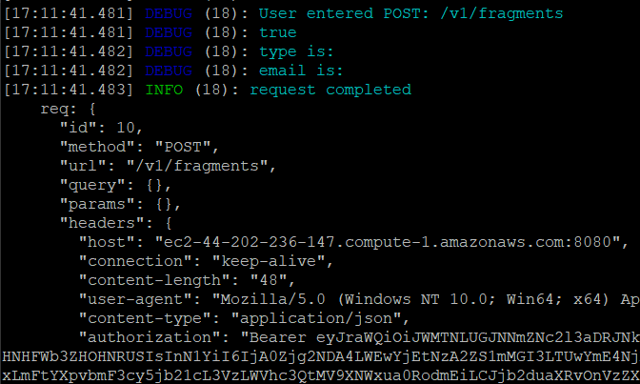
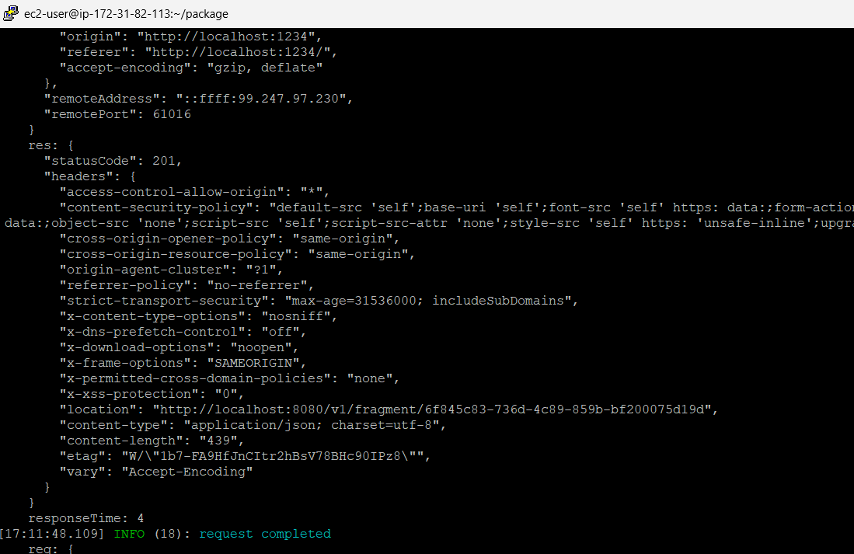
Npm Coverage
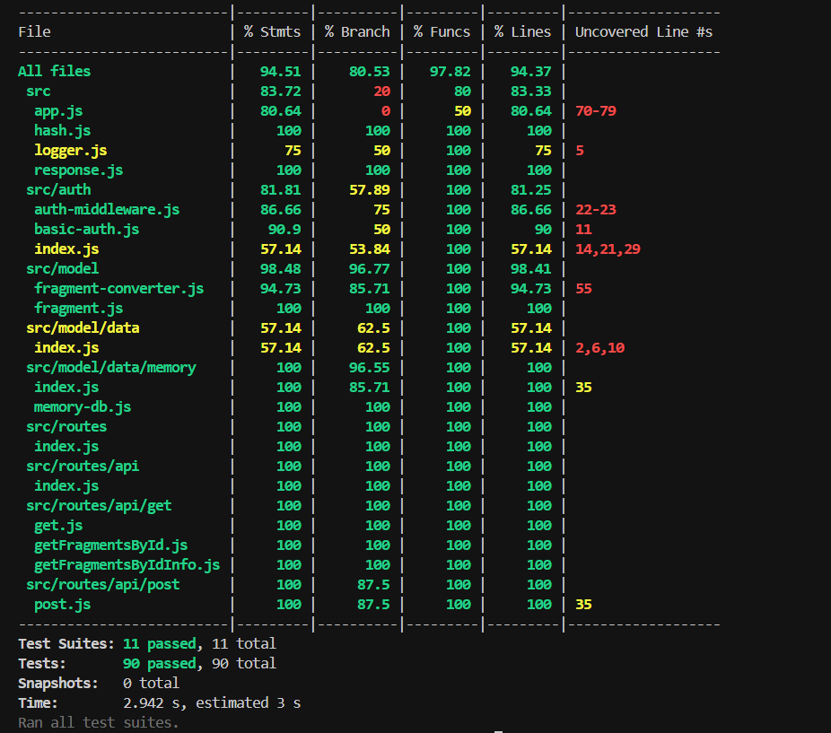

Conclusion:
Overall, the current state of the fragments microservice is a service where clients can login and be authenticated and authorized to create and access & convert some fragments. The biggest issue that needs to be addressed in the final release is finding a way to have environment variables work alongside nginx rather than hard coding/baking them into the image.

